

**Geethanjali College of Engineering and Technology (Autonomous)**

**Accredited by NAAC with A+Grade;** **B.Tech. CSE, EEE, ECE accredited by NBA** Sy. No: 33 & 34, Cheeryal (V), Keesara (M), Medchal District, Telangana – 501301

**OFFICE OF IQAC**

**Z**

**Online Feedback report for A. Y. 2024-25 II-Semester Term-1**

**Department of Master of Business Administration**

# Year: I Section: MBA-A

|  |  |  |  |
| --- | --- | --- | --- |
| **S.No** | **Faculty Name** | **Subject Name** | **Percentile** |
| **1.** | Md. Sabir Hussain | Business Communication Lab (BC-LAB) | 87.33 |
| **2.** | G. Vijaya Lakshmi | Management and Organizational Behavior (MOB) | 93.22 |
| **3.** | Shainaz Begum | Business Economics (BE) | 89.39 |
| **4.** | M Naga Sulochana | Financial Reporting & Analysis (FRA) | 88.47 |
| **5.** | Mrs.S. Indira Kumari | Research Methodology and Statistical Analysis (RMSA) | 93.53 |
| **6.** | Dr. J. Pardha Saradhi | Legal and Business Environment (LBE) | 92.88 |
| **7.** | M Naga Sulochana | Business Ethics and Corporate Governance (BECG) | 86.98 |
| **8.** | Dr. A. Sita Madhavi | Statistical Data Analysis Lab (SD-LAB) | 88.35 |

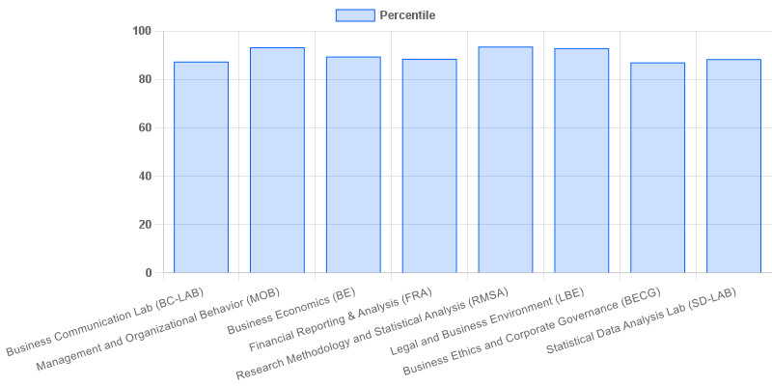

|  |  |  |  |
| --- | --- | --- | --- |
| **Coordinator-IQAC** | **Dean-IQAC** | **Principal** | **Director** |