

**Geethanjali College of Engineering and Technology (Autonomous)**

**Accredited by NAAC with A+Grade;** **B.Tech. CSE, EEE, ECE accredited by NBA** Sy. No: 33 & 34, Cheeryal (V), Keesara (M), Medchal District, Telangana – 501301

**OFFICE OF IQAC**

**Z**

**Online Feedback report for A. Y. 2024-25 II-Semester Term-1**

**Department of Electrical and Electronics Engineering**

# Year: I Section: EEE-A

|  |  |  |  |
| --- | --- | --- | --- |
| **S.No** | **Faculty Name** | **Subject Name** | **Percentile** |
| **1.** | Dr. Madhuri | Engineering Chemistry | 76.26 |
| **2.** | Dr. Madhuri | Engineering Chemistry Lab | 77.17 |
| **3.** | J. Sudhakar | Programming for Problem Solving- II | 75.32 |
| **4.** | J. Sudhakar | Programming for Problem Solving- II Lab | 76.12 |
| **5.** | G. Venkateshwarlu | Semiconductor Devices and Circuits | 80.32 |
| **6.** | G. Venkateshwarlu | Semiconductor Devices and Circuits Lab | 75.72 |
| **7.** | Dr. SK Nuslin Bibi | Multi Variable Calculus | 86.95 |
| **8.** | A. Ramesh | Computational Mathematics | 84.79 |
| **9.** | A. Ramesh | Computational Mathematics Lab | 85.26 |

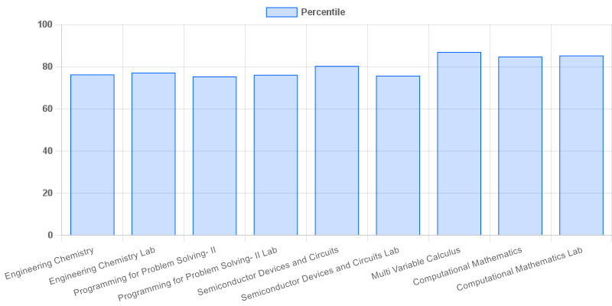

|  |  |  |  |
| --- | --- | --- | --- |
| **Coordinator-IQAC** | **Dean-IQAC** | **Principal** | **Director** |