

**Geethanjali College of Engineering and Technology (Autonomous)**

**Accredited by NAAC with A+Grade;** **B.Tech. CSE, EEE, ECE accredited by NBA** Sy. No: 33 & 34, Cheeryal (V), Keesara (M), Medchal District, Telangana – 501301

**OFFICE OF IQAC**

**Z**

**Online Feedback report for A. Y. 2024-25 II-Semester Term-1**

**Department of Electronics and Communication Engineering**

# Year: IV Section: ECE-A

|  |  |  |  |
| --- | --- | --- | --- |
| **S.No** | **Faculty Name** | **Subject Name** | **Percentile** |
| **1.** | Dr. N. Mahendra | Disaster Management (CE) | 77.18 |
| **2.** | Dr.B.Ramu | Radar Systems | 80.92 |
| **3.** | G. Venkateshwarlu | Technical Seminar | 80.1 |
| **4.** | Ms.B.Sreelatha | Project | 77.79 |
| **5.** | Veeramalla Shivani | Project Management and Finance | 85.95 |

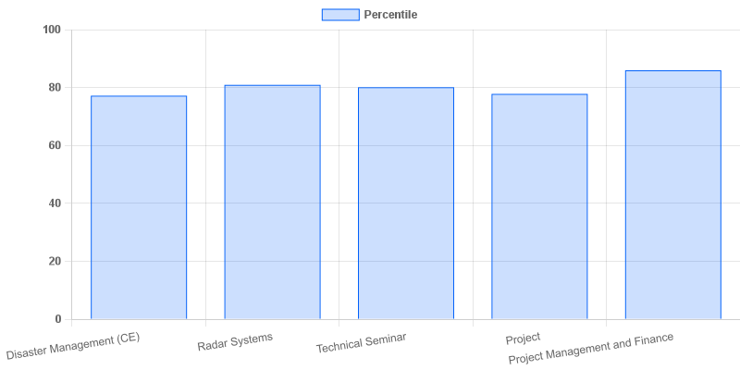

fig: ECE: 4-II-A

# Year: IV Section: ECE-B

|  |  |  |  |
| --- | --- | --- | --- |
| **S.No** | **Faculty Name** | **Subject Name** | **Percentile** |
| **1.** | D. Varun Kumar | Disaster Management (CE) | 82.44 |
| **2.** | T. V. Chandra Sheker | Radar Systems | 84.44 |
| **3.** | VVSVS Ramachandram | Technical Seminar | 84.22 |
| **4.** | Jagan Mohana Rao | Project | 85.22 |
| **5.** | Veeramalla Shivani | Project Management and Finance | 83 |

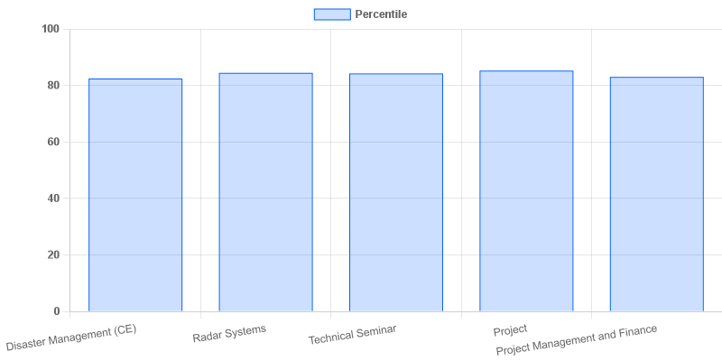

fig: ECE: 4-II-B

# Year: IV Section: ECE-C

|  |  |  |  |
| --- | --- | --- | --- |
| **S.No** | **Faculty Name** | **Subject Name** | **Percentile** |
| **1.** | G.Vimala | Disaster Management (CE) | 94.39 |
| **2.** | Nagalakshumma | Radar Systems | 95.16 |
| **3.** | D. Madhavi Latha | Technical Seminar | 94.19 |
| **4.** | L. Uma Maheshwari | Project | 96 |
| **5.** | K. Bhavana | Project Management and Finance | 95.03 |

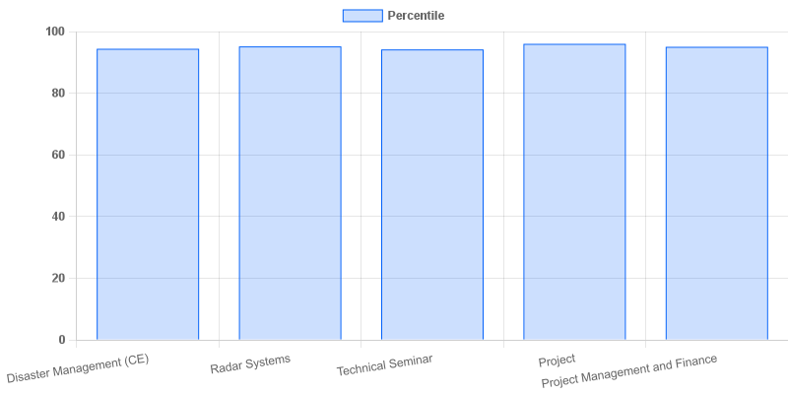

fig: ECE: 4-II-C

# Year: IV Section: ECE-D

|  |  |  |  |
| --- | --- | --- | --- |
| **S.No** | **Faculty Name** | **Subject Name** | **Percentile** |
| **1.** | G.Vimala | Disaster Management (CE) | 84.8 |
| **2.** | G. Ramachandra Kumar | Radar Systems | 85.94 |
| **3.** | Mr.K Victor | Technical Seminar | 87.2 |
| **4.** | Dr. U.Appala Raju | Project | 89.66 |
| **5.** | K. Bhavana | Project Management and Finance | 85.83 |

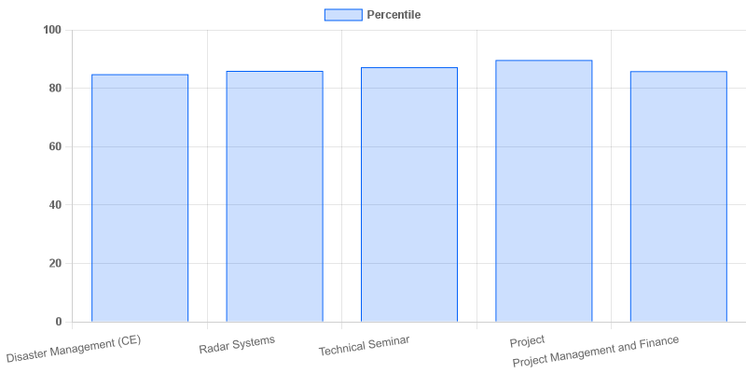

fig: ECE: 4-II-D

# Year: IV Section: ECE-E

|  |  |  |  |
| --- | --- | --- | --- |
| **S.No** | **Faculty Name** | **Subject Name** | **Percentile** |
| **1.** | D. Varun Kumar | Disaster Management (CE) | 88.83 |
| **2.** | Dr. Md. Shoukath Ali | 5G Mobile communications | 93.42 |
| **3.** | G. Ramachandra Kumar | Technical Seminar | 87.08 |
| **4.** | M. Sowjanya | Project | 87.17 |
| **5.** | K. Bhavana | Project Management and Finance | 89.5 |

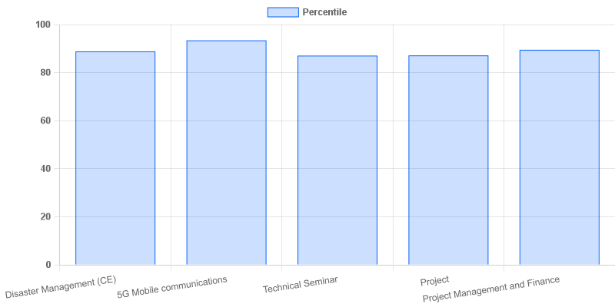

|  |  |  |  |
| --- | --- | --- | --- |
| **Coordinator-IQAC** | **Dean-IQAC** | **Principal** | **Director** |