

**Geethanjali College of Engineering and Technology (Autonomous)**

**Accredited by NAAC with A+Grade;** **B.Tech. CSE, EEE, ECE accredited by NBA** Sy. No: 33 & 34, Cheeryal (V), Keesara (M), Medchal District, Telangana – 501301

**OFFICE OF IQAC**

**Z**

**Online Feedback report for A. Y. 2024-25 II-Semester Term-1**

**Department of CSE-** **Data Science**

# Year: II Section: CSE-DS-A

|  |  |  |  |
| --- | --- | --- | --- |
| **S.No** | **Faculty Name** | **Subject Name** | **Percentile** |
| **1.** | V. Goutham | Building Technology (CE) | 80.63 |
| **2.** | B. Venkateswarlu | Design and Analysis of Algorithms | 79.73 |
| **3.** | M. ANUSHA SRI | Computer Architecture and Assembly Language Programming | 77.18 |
| **4.** | G. Raja sri | Operating Systems | 86.51 |
| **5.** | Dr. Madhira Srinivas | Web Technologies | 83.57 |
| **6.** | B. Venkateswarlu | Design and Analysis of Algorithms Lab | 79.71 |
| **7.** | G. Raja sri | Operating Systems and Assembly Language Programming Lab | 83.82 |
| **8.** | Dr. Madhira Srinivas | Web Technologies Lab | 85.34 |
| **9.** | S. Tirupathi Rao | Design Thinking | 83.49 |
| **10.** | Md. Sabir Hussain | English for Career Development | 78.59 |

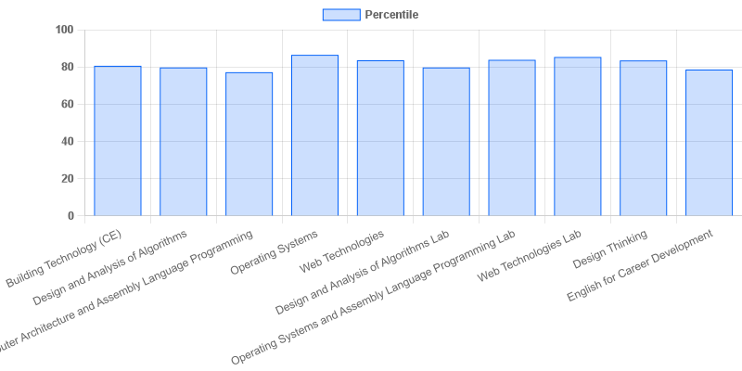

fig: DS: 2-II-A

# Year: II Section: CSE-DS-B

|  |  |  |  |
| --- | --- | --- | --- |
| **S.No** | **Faculty Name** | **Subject Name** | **Percentile** |
| **1.** | J.Sravani | Building Technology (CE) | 76.08 |
| **2.** | T. Pandu Ranga | Design and Analysis of Algorithms | 75.1 |
| **3.** | M. ANUSHA SRI | Computer Architecture and Assembly Language Programming | 70.69 |
| **4.** | G. Raja sri | Operating Systems | 73.14 |
| **5.** | Dr. Madhira Srinivas | Web Technologies | 75.06 |
| **6.** | T. Pandu Ranga | Design and Analysis of Algorithms Lab | 73.57 |
| **7.** | M. ANUSHA SRI | Operating Systems and Assembly Language Programming Lab | 70.82 |
| **8.** | Dr. Madhira Srinivas | Web Technologies Lab | 75.61 |
| **9.** | P. Shambhavi | Design Thinking | 73.22 |
| **10.** | D. Anuradha | English for Career Development | 76.69 |

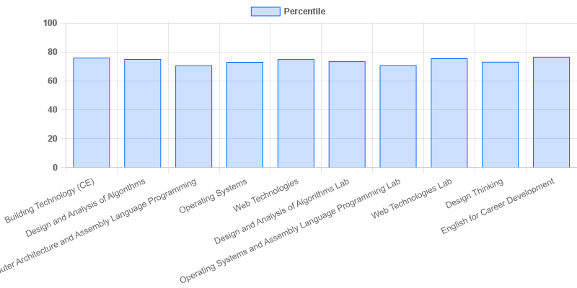

fig: DS: 2-II-B

# Year: II Section: CSE-DS-C

|  |  |  |  |
| --- | --- | --- | --- |
| **S.No** | **Faculty Name** | **Subject Name** | **Percentile** |
| **1.** | J.Sravani | Building Technology (CE) | 88.36 |
| **2.** | T. Pandu Ranga | Design and Analysis of Algorithms | 81.84 |
| **3.** | RAMA ARUNA | Computer Architecture and Assembly Language Programming | 74.76 |
| **4.** | Dr. L. Kiran Kumar Reddy | Operating Systems | 79.8 |
| **5.** | G. Vijay Kumar | Web Technologies | 80.12 |
| **6.** | T. Pandu Ranga | Design and Analysis of Algorithms Lab | 81.55 |
| **7.** | Dr. L. Kiran Kumar Reddy | Operating Systems and Assembly Language Programming Lab | 78.25 |
| **8.** | G. Vijay Kumar | Web Technologies Lab | 81.55 |
| **9.** | Anshu Kunwar | Design Thinking | 71.68 |
| **10.** | D. Anuradha | English for Career Development | 79.68 |

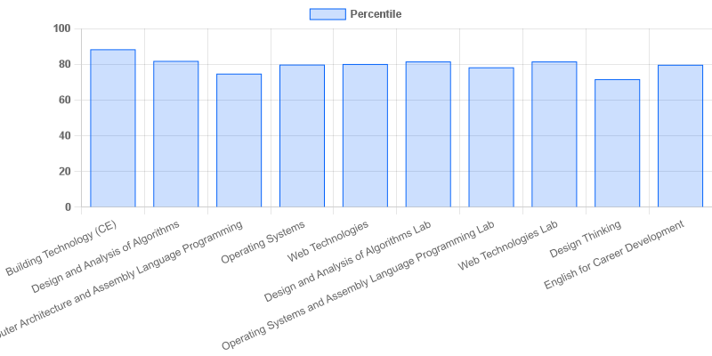

fig: DS: 2-II-C

# Year: II Section: CSE-DS-D

|  |  |  |  |
| --- | --- | --- | --- |
| **S.No** | **Faculty Name** | **Subject Name** | **Percentile** |
| **1.** | J.Sravani | Building Technology (CE) | 86.75 |
| **2.** | B. Venkateswarlu | Design and Analysis of Algorithms | 90.9 |
| **3.** | RAMA ARUNA | Computer Architecture and Assembly Language Programming | 79.53 |
| **4.** | Dr. L. Kiran Kumar Reddy | Operating Systems | 81.06 |
| **5.** | G. Vijay Kumar | Web Technologies | 78.24 |
| **6.** | B. Venkateswarlu | Design and Analysis of Algorithms Lab | 88.53 |
| **7.** | RAMA ARUNA | Operating Systems and Assembly Language Programming Lab | 80.34 |
| **8.** | G. Vijay Kumar | Web Technologies Lab | 79.75 |
| **9.** | Anshu Kunwar | Design Thinking | 80.16 |
| **10.** | D. Anuradha | English for Career Development | 86.47 |

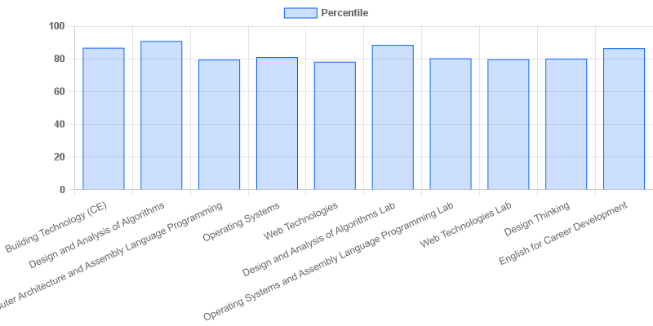

|  |  |  |  |
| --- | --- | --- | --- |
| **Coordinator-IQAC** | **Dean-IQAC** | **Principal** | **Director** |