

**Geethanjali College of Engineering and Technology (Autonomous)**

**Accredited by NAAC with A+Grade;** **B.Tech. CSE, EEE, ECE accredited by NBA** Sy. No: 33 & 34, Cheeryal (V), Keesara (M), Medchal District, Telangana – 501301

**OFFICE OF IQAC**

**Z**

**Online Feedback report for A. Y. 2024-25 II-Semester Term-1**

**Department of CSE-** **Data Science**

# Year: I Section: CSE-DS-A

|  |  |  |  |
| --- | --- | --- | --- |
| **S.No** | **Faculty Name** | **Subject Name** | **Percentile** |
| **1.** | Keerthi | Programming for Problem Solving- II | 87.46 |
| **2.** | N. MADHIVI | Discrete Mathematics | 72 |
| **3.** | Keerthi | Programming for Problem Solving- II Lab | 89.13 |
| **4.** | Md. Hafeezuddin | Basic Electrical Engineering | 91.62 |
| **5.** | Md. Hafeezuddin | Basic Electrical Engineering Lab | 85.72 |
| **6.** | Dr. G.Srinivas | Multi Variable Calculus | 86.77 |
| **7.** | V. Navaneetha | Engineering Graphics | 82.96 |
| **8.** | R. Satya Mahipal Reddy | Engineering Workshop | 88.7 |
| **9.** | B. Ramesh | Semiconductor Devices | 76.54 |
| **10.** | B. Ramesh | Semiconductor Devices Lab | 83.17 |

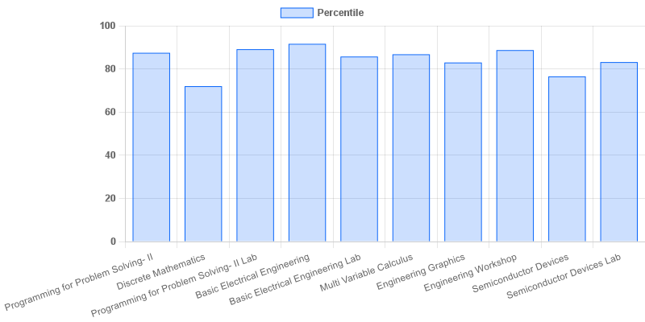

fig: DS: 1-II-A

# Year: I Section: CSE-DS-B

|  |  |  |  |
| --- | --- | --- | --- |
| **S.No** | **Faculty Name** | **Subject Name** | **Percentile** |
| **1.** | Keerthi | Programming for Problem Solving- II | 84.18 |
| **2.** | N. MADHIVI | Discrete Mathematics | **66.04** |
| **3.** | Keerthi | Programming for Problem Solving- II Lab | 84.14 |
| **4.** | Lingappa. J | Basic Electrical Engineering | 72.04 |
| **5.** | Lingappa. J | Basic Electrical Engineering Lab | 70.18 |
| **6.** | Dr M Hemantha Lakshmi | Multi Variable Calculus | 83.75 |
| **7.** | G. Raju | Engineering Graphics | 80.51 |
| **8.** | B Bhavsingh | Engineering Workshop | 80.68 |
| **9.** | A. Shiva Kumar | Semiconductor Devices | 79.82 |
| **10.** | A. Shiva Kumar | Semiconductor Devices Lab | 79.14 |

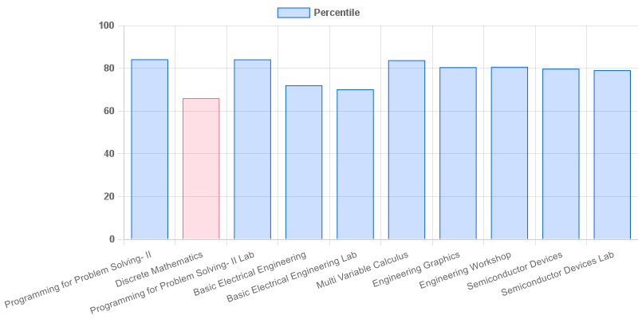

fig: DS: 1-II-B

# Year: I Section: CSE-DS-C

|  |  |  |  |
| --- | --- | --- | --- |
| **S.No** | **Faculty Name** | **Subject Name** | **Percentile** |
| **1.** | K. Srilatha | Programming for Problem Solving- II | 78.92 |
| **2.** | G. Raga Mounika | Discrete Mathematics | 82.48 |
| **3.** | K. Srilatha | Programming for Problem Solving- II Lab | 81.9 |
| **4.** | B. Srujana | Basic Electrical Engineering | 86.28 |
| **5.** | B. Srujana | Basic Electrical Engineering Lab | 85.25 |
| **6.** | G. Kalpana | Multi Variable Calculus | 88.68 |
| **7.** | P. Sandeep Kumar | Engineering Graphics | 79.68 |
| **8.** | P. Sathish | Engineering Workshop | 83.25 |
| **9.** | Dr. V. Kamalaker | Semiconductor Devices | 83.96 |
| **10.** | Dr. V. Kamalaker | Semiconductor Devices Lab | 84.15 |

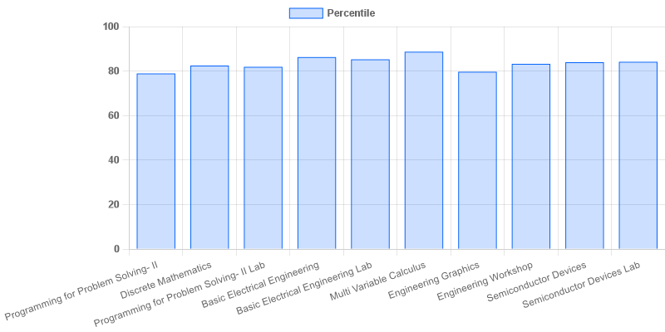

fig: DS: 1-II-C

|  |  |  |  |
| --- | --- | --- | --- |
| **Coordinator-IQAC** | **Dean-IQAC** | **Principal** | **Director** |