

**Geethanjali College of Engineering and Technology (Autonomous)**

**Accredited by NAAC with A+Grade;** **B.Tech. CSE, EEE, ECE accredited by NBA** Sy. No: 33 & 34, Cheeryal (V), Keesara (M), Medchal District, Telangana – 501301

**OFFICE OF IQAC**

**Z**

**Online Feedback report for A. Y. 2024-25 II-Semester Term-1**

**Department of Computer Science and Engineering**

# Year: III Section: CSE-A

|  |  |  |  |
| --- | --- | --- | --- |
| **S.No** | **Faculty Name** | **Subject Name** | **Percentile** |
| **1.** | Reena Rana | Green Buildings (OE - II) | 84.98 |
| **2.** | Dr. S Radha | Internet of Things | 88.39 |
| **3.** | P. Lalitha | Information Retrieval Systems (PE - I) | 82.75 |
| **4.** | P. Krishna Rao | Distribution Systems (PE - II) | 81.18 |
| **5.** | Dr. S Radha | Internet of Things Lab | 88.09 |
| **6.** | Dr P Narasimha Raju | English for Professional Success | 84.9 |
| **7.** | G. Durga Priyadarsini | Statistics for Machine Learning | 92.24 |
| **8.** | G. Durga Priyadarsini | Statistics for Machine Learning Lab | 90.74 |
| **9.** | Dr. G. Srinivas | Logical Reasoning - II | 87.57 |
| **10.** | A. Shiva Jyothi | Professional Ethics | 76.04 |

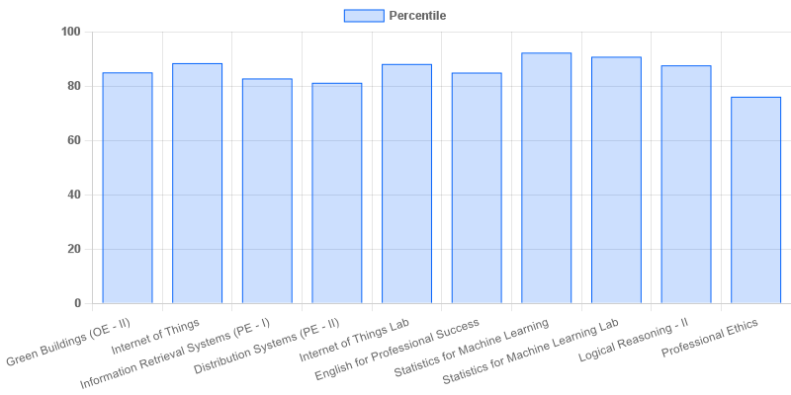

fig: CSE: 3-II-A

# Year: III Section: CSE-B

|  |  |  |  |
| --- | --- | --- | --- |
| **S.No** | **Faculty Name** | **Subject Name** | **Percentile** |
| **1.** | Dr. PVSN PAVAN KUMAR | Green Buildings (OE - II) | 85.13 |
| **2.** | Dr. S Radha | Internet of Things | 88.26 |
| **3.** | P. Lalitha | Information Retrieval Systems (PE - I) | 87.39 |
| **4.** | Dr. K. Kamakshaiah | Block Chain Technologies (PE - II) | 85.7 |
| **5.** | Dr. S Radha | Internet of Things Lab | 87.93 |
| **6.** | Dr. Vanisree | English for Professional Success | 87.3 |
| **7.** | Dr.P.Rahira | Statistics for Machine Learning | 90.26 |
| **8.** | Dr.P.Rahira | Statistics for Machine Learning Lab | 87.93 |
| **9.** | Dr. G. Srinivas | Logical Reasoning - II | 88.13 |
| **10.** | A. Shiva Jyothi | Professional Ethics | 79.04 |

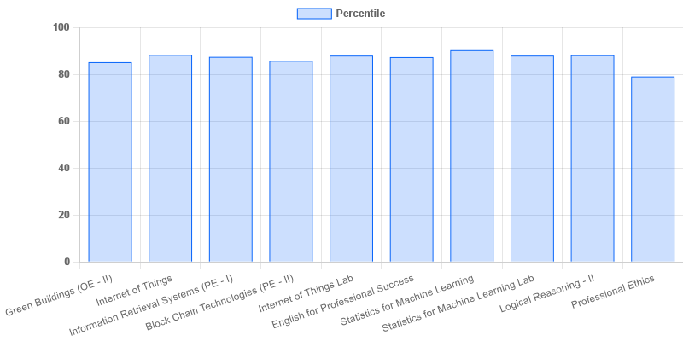

fig: CSE: 3-II-B

# Year: III Section: CSE-C

|  |  |  |  |
| --- | --- | --- | --- |
| **S.No** | **Faculty Name** | **Subject Name** | **Percentile** |
| **1.** | Dr. PVSN PAVAN KUMAR | Green Buildings (OE - II) | 70.36 |
| **2.** | G. Santhoshi | Internet of Things | 77.86 |
| **3.** | A. Rahul | Cryptography and Network Security (PE - I) | 74 |
| **4.** | Dr. K. Kamakshaiah | Block Chain Technologies (PE - II) | 78.84 |
| **5.** | G. Santhoshi | Internet of Things Lab | 80.68 |
| **6.** | Dr. Vanisree | English for Professional Success | 86.36 |
| **7.** | Dr. Vemula. Suseela Triveni | Statistics for Machine Learning | 85.59 |
| **8.** | Dr. A. Srinivasulu | Statistics for Machine Learning Lab | 77.22 |
| **9.** | Dr M Hemantha Lakshmi | Logical Reasoning - II | 82.09 |
| **10.** | A. Shiva Jyothi | Professional Ethics | 78.5 |

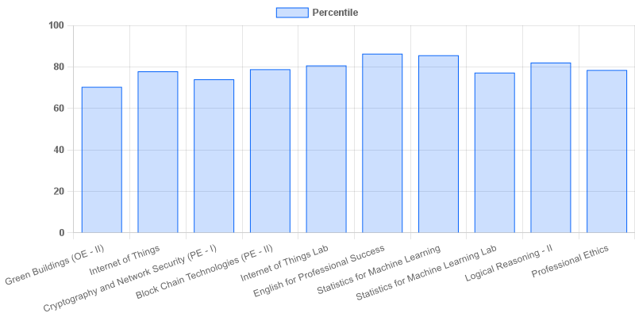

fig: CSE: 3-II-C

# Year: III Section: CSE-D

|  |  |  |  |
| --- | --- | --- | --- |
| **S.No** | **Faculty Name** | **Subject Name** | **Percentile** |
| **1.** | Dr. K. Sri Lakshmi | Green Buildings (OE - II) | 82.89 |
| **2.** | E. Mahender | Internet of Things | 88.8 |
| **3.** | K. Ashwini | Design Patterns (PE - I) | 72.84 |
| **4.** | P. Krishna Rao | Distribution Systems (PE - II) | 81.16 |
| **5.** | E. Mahender | Internet of Things Lab | 89 |
| **6.** | Dr Mudasir Ahmad Lone | English for Professional Success | 90.76 |
| **7.** | Dr.P.Rahira | Statistics for Machine Learning | 95.02 |
| **8.** | Dr.P.Rahira | Statistics for Machine Learning Lab | 94.67 |
| **9.** | G. Durga Priyadarsini | Logical Reasoning - II | 91.64 |
| **10.** | MD. Naseeruddin | Professional Ethics | 77.78 |

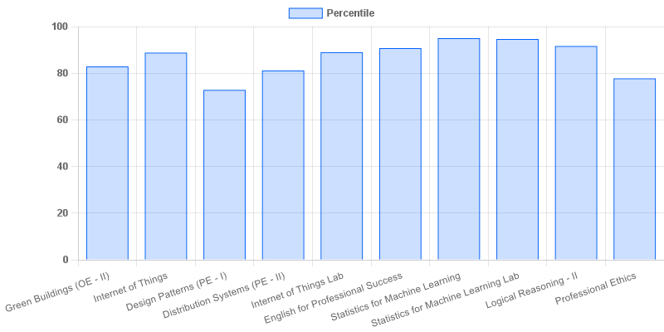

fig: CSE: 3-II-D

# Year: III Section: CSE-E

|  |  |  |  |
| --- | --- | --- | --- |
| **S.No** | **Faculty Name** | **Subject Name** | **Percentile** |
| **1.** | E. Mahender | Internet of Things | 82.78 |
| **2.** | K. Ashwini | Design Patterns (PE - I) | 80.06 |
| **3.** | D. Venkateswarlu | Principles of Programming Languages | 80.64 |
| **4.** | S. Durga Prasad | Block Chain Technologies (PE - II) | 84.57 |
| **5.** | E. Mahender | Internet of Things Lab | 83.54 |
| **6.** | Dr Mudasir Ahmad Lone | English for Professional Success | 83.67 |
| **7.** | Dr. A. Srinivasulu | Statistics for Machine Learning | 76.78 |
| **8.** | Dr. A. Srinivasulu | Statistics for Machine Learning Lab | 75.28 |
| **9.** | Dr. P. Sarada Devi | Logical Reasoning - II | 86 |
| **10.** | K. Naupal Reddy | Supply Chain Management (OE - II) | 72.78 |
| **11.** | MD. Naseeruddin | Professional Ethics | 74.56 |

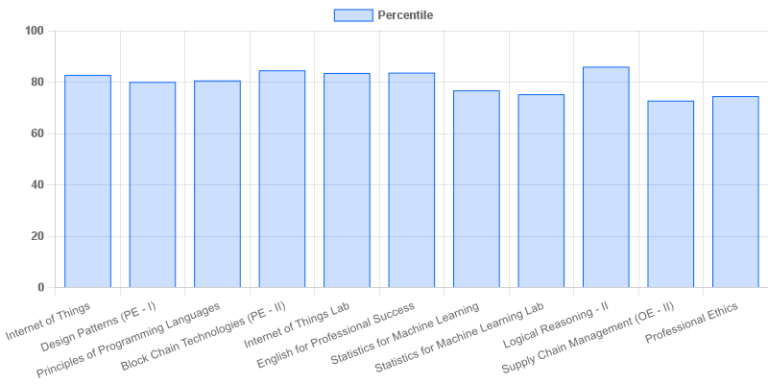

fig: CSE: 3-II-E

# Year: III Section: CSE-F

|  |  |  |  |
| --- | --- | --- | --- |
| **S.No** | **Faculty Name** | **Subject Name** | **Percentile** |
| **1.** | Dr. PVSN PAVAN KUMAR | Green Buildings (OE - II) | 75.64 |
| **2.** | Y. Siva | Internet of Things | 87.64 |
| **3.** | A. Rahul | Cryptography and Network Security (PE - I) | 75.42 |
| **4.** | S. Durga Prasad | Block Chain Technologies (PE - II) | 76.22 |
| **5.** | Y. Siva | Internet of Things Lab | 88.22 |
| **6.** | Dr P Narasimha Raju | English for Professional Success | 74.13 |
| **7.** | Dr. Vemula. Suseela Triveni | Statistics for Machine Learning | 68 |
| **8.** | Dr. Vemula. Suseela Triveni | Statistics for Machine Learning Lab | 80.22 |
| **9.** | Dr. SK Nuslin Bibi | Logical Reasoning - II | 88.58 |
| **10.** | G. Udaya Sri | Professional Ethics | 68.53 |

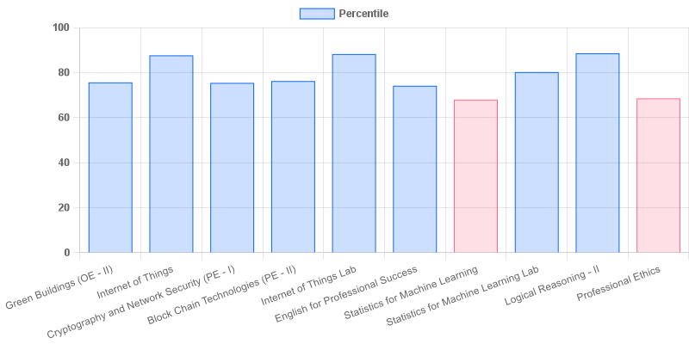

fig: CSE: 3-II-F

# Year: III Section: CSE-G

|  |  |  |  |
| --- | --- | --- | --- |
| **S.No** | **Faculty Name** | **Subject Name** | **Percentile** |
| **1.** | V. Goutham | Green Buildings (OE - II) | 66.52 |
| **2.** | Y. Siva | Internet of Things | 81.13 |
| **3.** | K. Srinivas | Information Retrieval Systems (PE - I) | 89.39 |
| **4.** | Dr. A. Hari Prasad Reddy | Block Chain Technologies (PE - II) | 80.09 |
| **5.** | Y. Siva | Internet of Things Lab | 83.15 |
| **6.** | Dr P Narasimha Raju | English for Professional Success | 75.52 |
| **7.** | Dr. A. Srinivasulu | Statistics for Machine Learning | 81.91 |
| **8.** | Dr. A. Srinivasulu | Statistics for Machine Learning Lab | 80.49 |
| **9.** | Dr. SK Nuslin Bibi | Logical Reasoning - II | 86.26 |
| **10.** | G. Udaya Sri | Professional Ethics | 76.17 |

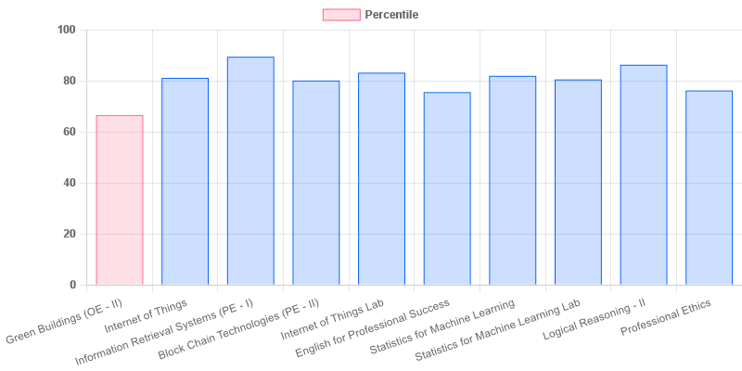

fig: CSE: 3-II-G

|  |  |  |  |
| --- | --- | --- | --- |
| **Coordinator-IQAC** | **Dean-IQAC** | **Principal** | **Director** |