

**Geethanjali College of Engineering and Technology (Autonomous)**

**Accredited by NAAC with A+Grade;** **B.Tech. CSE, EEE, ECE accredited by NBA** Sy. No: 33 & 34, Cheeryal (V), Keesara (M), Medchal District, Telangana – 501301

**OFFICE OF IQAC**

**Z**

**Online Feedback report for A. Y. 2024-25 II-Semester Term-1**

**Department of CSE-** **Cyber Security**

# Year: IV Section: CSE-CS-A

|  |  |  |  |
| --- | --- | --- | --- |
| **S.No** | **Faculty Name** | **Subject Name** | **Percentile** |
| **1.** | N. Srikanth | Disaster Management (CE) | 83.41 |
| **2.** | V. Soujenya | Human Computer Interaction (HCI) | 87 |
| **3.** | M Naga Sulochana | Project Management and Finance | 84.53 |

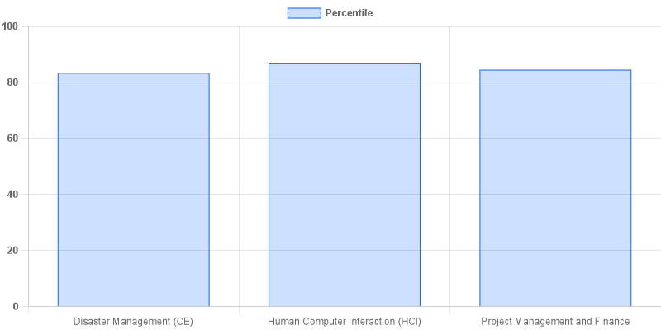

fig: CS: 4-II-A`

|  |  |  |  |
| --- | --- | --- | --- |
| **Coordinator-IQAC** | **Dean-IQAC** | **Principal** | **Director** |