

**Geethanjali College of Engineering and Technology (Autonomous)**

**Accredited by NAAC with A+Grade;** **B.Tech. CSE, EEE, ECE accredited by NBA** Sy. No: 33 & 34, Cheeryal (V), Keesara (M), Medchal District, Telangana – 501301

**OFFICE OF IQAC**

**Z**

**Online Feedback report for A. Y. 2024-25 II-Semester Term-1**

**Department of CSE-** **Cyber Security**

# Year: III Section: CSE-CS-A

|  |  |  |  |
| --- | --- | --- | --- |
| **S.No** | **Faculty Name** | **Subject Name** | **Percentile** |
| **1.** | M. Prajwala Priyanka | Machine Learning | 82.23 |
| **2.** | G. Lokeshwari | Information Security | 89.31 |
| **3.** | Sharban Kumar Apat | Digital Forensics | 80.2 |
| **4.** | Nikhate Yuvraj Dhanaji | Distribution Systems (PE - II) | 67.77 |
| **5.** | Dr.B.Dhanalaxmi | Software Engineering | 86.43 |
| **6.** | M. Prajwala Priyanka | Machine Learning Lab | 81.89 |
| **7.** | G. Lokeshwari | Information Security Lab and Digital Forensics Lab | 85.94 |
| **8.** | Dr.C.Goverdhan | Professional Communication Skills Lab | 77.42 |
| **9.** | A. Ramesh | Logical Reasoning - II | 78.33 |
| **10.** | Shakira | Professional Ethics | 71.44 |

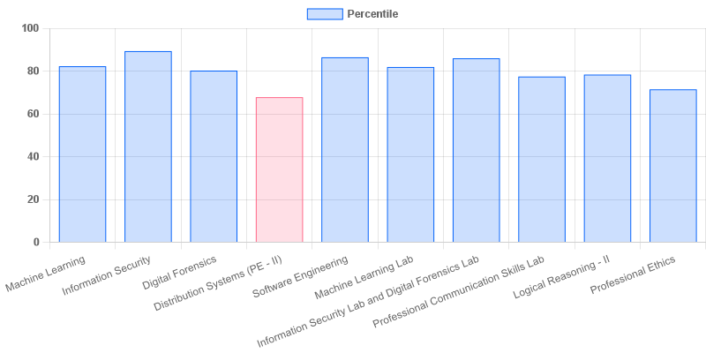

|  |  |  |  |
| --- | --- | --- | --- |
| **Coordinator-IQAC** | **Dean-IQAC** | **Principal** | **Director** |

fig: CS: 3-II-A