

**Geethanjali College of Engineering and Technology (Autonomous)**

**Accredited by NAAC with A+Grade;** **B.Tech. CSE, EEE, ECE accredited by NBA** Sy. No: 33 & 34, Cheeryal (V), Keesara (M), Medchal District, Telangana – 501301

**OFFICE OF IQAC**

**Z**

**Online Feedback report for A. Y. 2024-25 II-Semester Term-1**

**Department of Civil Engineering**

# Year: III Section: CIVIL-A

|  |  |  |  |
| --- | --- | --- | --- |
| **S.No** | **Faculty Name** | **Subject Name** | **Percentile** |
| **1.** | M. Supriya | Hydrology and Water Resources | 91.55 |
| **2.** | V. Navaneetha | Environmental Engineering | 94.55 |
| **3.** | G. Sampath Kumar | Design of Steel Structures | 97.91 |
| **4.** | Dr. PVSN PAVAN KUMAR | Foundation Engineering | 88.91 |
| **5.** | Dr. K. Sri Lakshmi | Green Building Systems | 90 |
| **6.** | V. Navaneetha | Environmental Engineering Lab | 92.73 |
| **7.** | D. Varun Kumar | Structural Drafting Lab | 91.02 |
| **8.** | Dr.C.Goverdhan | Professional Communication Skills Lab | 86.14 |
| **9.** | G. Durga Priyadarsini | Logical Reasoning - II | 88.27 |

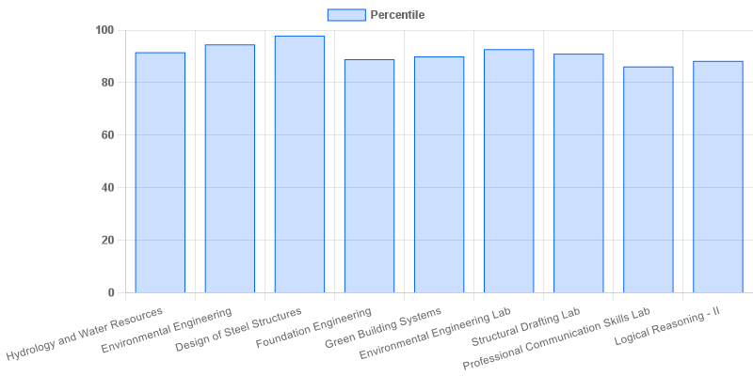

fig: CIVIL: 3-II-A

|  |  |  |  |
| --- | --- | --- | --- |
| **Coordinator-IQAC** | **Dean-IQAC** | **Principal** | **Director** |