

**Geethanjali College of Engineering and Technology (Autonomous)**

**Accredited by NAAC with A+Grade;** **B.Tech. CSE, EEE, ECE accredited by NBA** Sy. No: 33 & 34, Cheeryal (V), Keesara (M), Medchal District, Telangana – 501301

**OFFICE OF IQAC**

**Z**

**Online Feedback report for A. Y. 2024-25 II-Semester Term-1**

**Department of Civil Engineering**

# Year: II Section: CIVIL-A

|  |  |  |  |
| --- | --- | --- | --- |
| **S.No** | **Faculty Name** | **Subject Name** | **Percentile** |
| **1.** | Dr. V. V. Praveen Kumar | Structural Analysis | 95.62 |
| **2.** | D. Varun Kumar | Hydraulics and Hydraulic Machinery | 99.14 |
| **3.** | Dr. R. Prasanna Kumar | Concrete Technology | 95.9 |
| **4.** | G.Vimala | Computer Aided Drafting of Buildings Lab | 95.24 |
| **5.** | D. Varun Kumar | Fluid Mechanics and Hydraulic Machinery Lab | 98.1 |
| **6.** | Dr. Imtiyaz Ahmad Dar | English for Career Development | 93.81 |
| **7.** | A. Ramesh | Computational Mathematics | 95.52 |
| **8.** | A. Ramesh | Computational Mathematics Lab | 95 |
| **9.** | G. Vijaya Lakshmi | Intellectual Property Rights (MBA) | 96.48 |

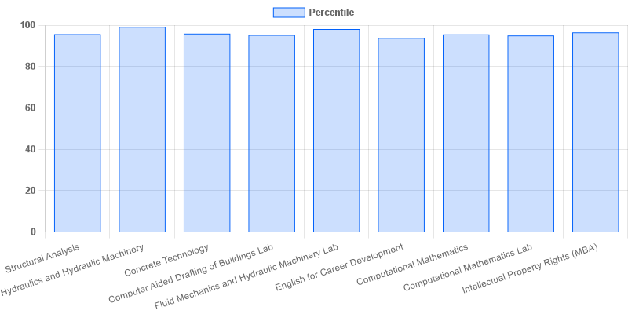

fig: CIVIL: 2-II-A

|  |  |  |  |
| --- | --- | --- | --- |
| **Coordinator-IQAC** | **Dean-IQAC** | **Principal** | **Director** |