

**Geethanjali College of Engineering and Technology (Autonomous)**

**Accredited by NAAC with A+Grade;** **B.Tech. CSE, EEE, ECE accredited by NBA** Sy. No: 33 & 34, Cheeryal (V), Keesara (M), Medchal District, Telangana – 501301

**OFFICE OF IQAC**

**Z**

**Online Feedback report for A. Y. 2024-25 II-Semester Term-1**

**Department of Civil Engineering**

# Year: I Section: CIVIL-A

|  |  |  |  |
| --- | --- | --- | --- |
| **S.No** | **Faculty Name** | **Subject Name** | **Percentile** |
| **1.** | Dr. N. Mahendra | Engineering Geology | 82.2 |
| **2.** | Dr. N. Mahendra | Engineering Geology Lab( E. Geo Lab) | 82 |
| **3.** | Venkateswarlu | Design Thinking | 81.8 |
| **4.** | Dr. P. Sreedhar | Engineering Chemistry | 80.4 |
| **5.** | Dr. P. Sreedhar | Engineering Chemistry Lab | 82.38 |
| **6.** | P. Sobha Rani | Programming for Problem Solving- II | 88.9 |
| **7.** | P. Sobha Rani | Programming for Problem Solving- II Lab | 86.5 |
| **8.** | Y Anil | English | 86.9 |
| **9.** | Y Anil | English Language Communication Skills Lab | 88 |
| **10.** | Nagi Reddy | Multi Variable Calculus | 87.1 |

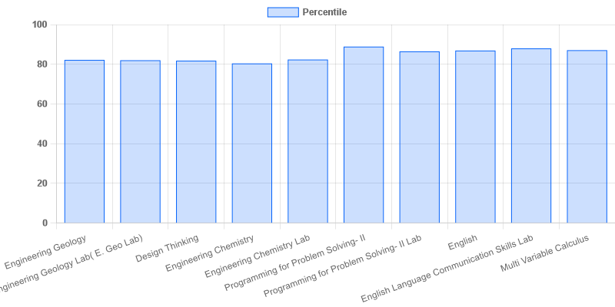

fig: CIVIL: 1-II-A

|  |  |  |  |
| --- | --- | --- | --- |
| **Coordinator-IQAC** | **Dean-IQAC** | **Principal** | **Director** |