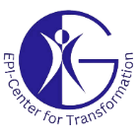
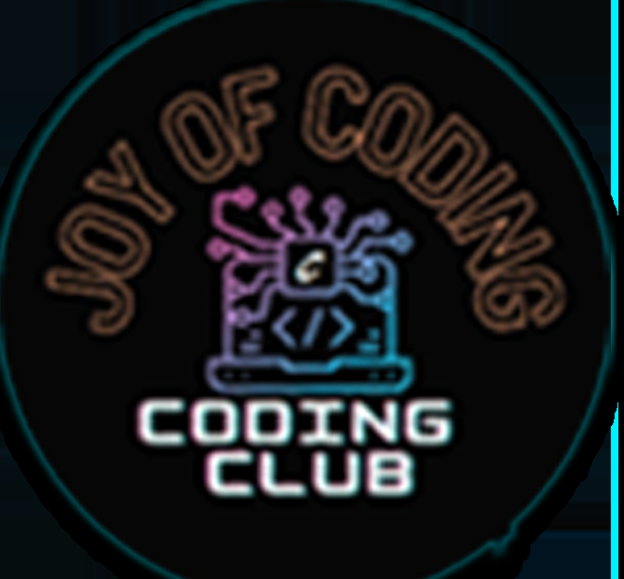
Geethanjali College of Engineering and Technology
(UGC Autonomous)
Accredited by NAAC with A⁺ Grade; B.Tech. CSE, EEE, ECE Accredited by NBA;
Approved by AICTE, New Delhi; Affiliated to JNTUH, Hyderabad;
Cheeryal (V), Keesara (M), Medchal-Malkajgiri Dist., Telangana-501301
Session Details:
Title of the Session: Guest Lecture on Coding Platforms & Career Pathways
Start Date & End Date (DD-MM-YY format): 31st October,2025
Duration: 2 Hours (1:30 PM to 3:50 PM)
Activity Category: Self Driven
Theme: Innovation and Skill Development
Speaker Details:
- Name: Mr. Nikhil Guru Venkatesh
- Designation: AI Architect & Strategist
- Organization: Techolution
Mr. Nikhil Guru Venkatesh is an accomplished AI Architect & Strategist with extensive experience in designing intelligent systems, developing large-scale AI solutions, and driving technology innovation in the software industry. He is associated with Techolution, where he contributes to strategic AI initiatives, digital transformation projects, and enterprise-level automation solutions.With strong expertise in Artificial Intelligence, Machine Learning, Cloud Technologies, and Modern Software Development, he has led several high-impact projects across domains such as finance, healthcare, manufacturing, and smart automation. His work focuses on building scalable architectures, optimizing development pipelines, and enabling organizations to adopt cutting-edge AI capabilities.
Mr. Nikhil is also a passionate mentor and speaker, committed to empowering students and young professionals. He frequently delivers sessions on:
- Coding best practices and problem-solving techniques
- Competitive programming and coding interview preparation
- Emerging technologies including AI, data science, and cloud computing
- Career pathways in software development and the IT industry
Known for his engaging speaking style and industry-driven insights, he inspires students to strengthen their technical foundations, explore innovation, and pursue impactful careers in technology.

Objective:
- To enhance student awareness about various coding platforms and tools.
- To introduce competitive programming opportunities and their benefits.
- To motivate students to participate actively in coding contests and hackathons.
- To provide career guidance related to software development, AI, and emerging technologies.
Benefit in terms of Learning / Skill / Knowledge obtained: Students gain clarity on using coding platforms like Lee code, Code Chef, Hacker rank.
Outcome of the Activity: Increased interest and participation in competitive programming and hackathons.
- Improved understanding of programming fundamentals and problem-solving strategies.
- Awareness of industry expectations, AI applications, and future technology career paths.
- Enhanced motivation to pursue skill development beyond academics.
.
Relevant SDGs
- SDG 4 – Quality Education
Enhances students’ knowledge of coding platforms, competitive programming, and emerging technologies, thereby supporting quality technical education.
- SDG 8 – Decent Work and Economic Growth
Provides career guidance and industry exposure, helping students develop employability skills relevant to the software and IT sectors.
- SDG 9 – Industry, Innovation and Infrastructure
Encourages innovation and awareness of modern technologies such as AI, machine learning, and cloud computing used in industry.
Program Outcomes mapped
- PO1 – Engineering Knowledge
Strengthened students’ understanding of programming fundamentals, algorithms, and software development concepts.
- PO2 – Problem Analysis
Improved students’ ability to analyze coding problems and select appropriate problem-solving strategies.
- PO3 – Design/Development of Solutions
Exposed students to structured approaches for designing efficient and scalable software solutions.
- PO5 – Modern Tool Usage
Introduced students to modern coding platforms and development tools used for competitive programming and interviews.
- PO9– Individual and Team Work
Encouraged collaborative learning and peer interaction during discussions on contests and hackathons.
- PO11 – Life-long Learning
Motivated students to pursue continuous learning, self-upskilling, and participation in coding competitions beyond academics.
Key Highlights: Enhanced motivation to pursue skill development beyond academics.
Participant Details: 102 Students
Total number of Student Participation (Internal / External if any): 102 (Internal)
Total number of Staff (Teaching / Non-Teaching) Participation: 7 (Teaching Faculty Coordinators from Coding Club)
Geotagged Photographs: Attached
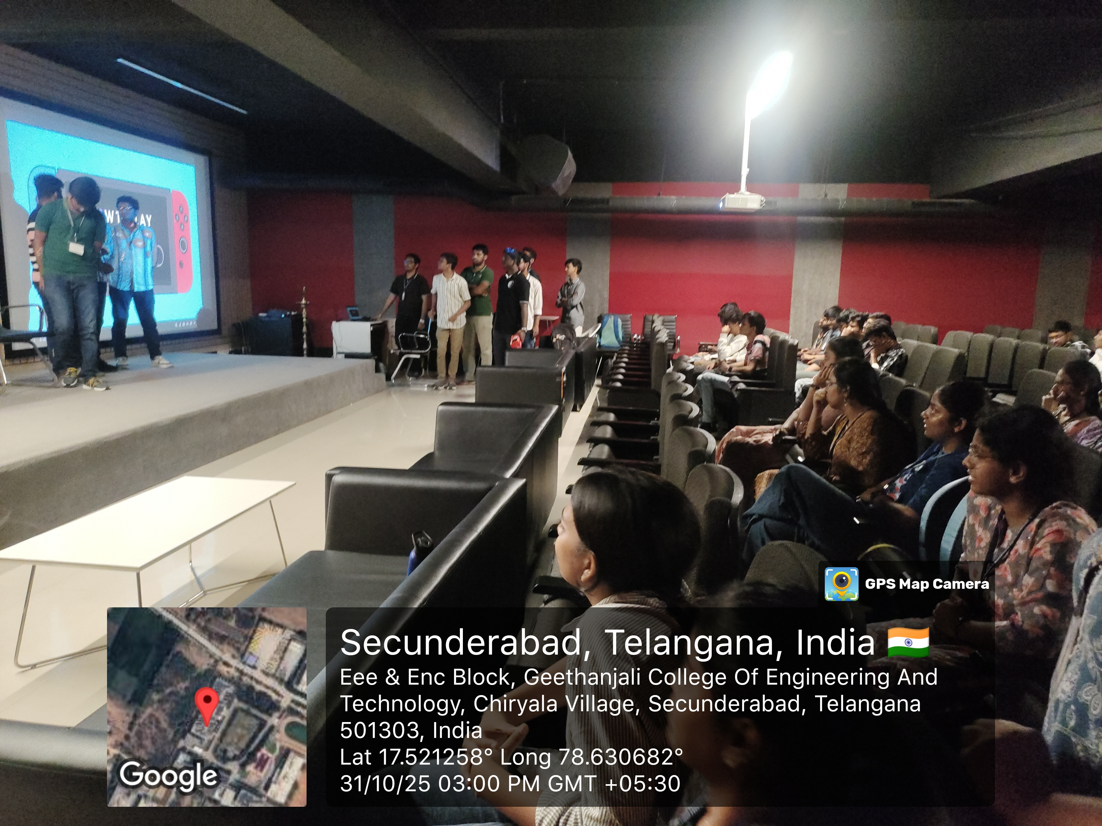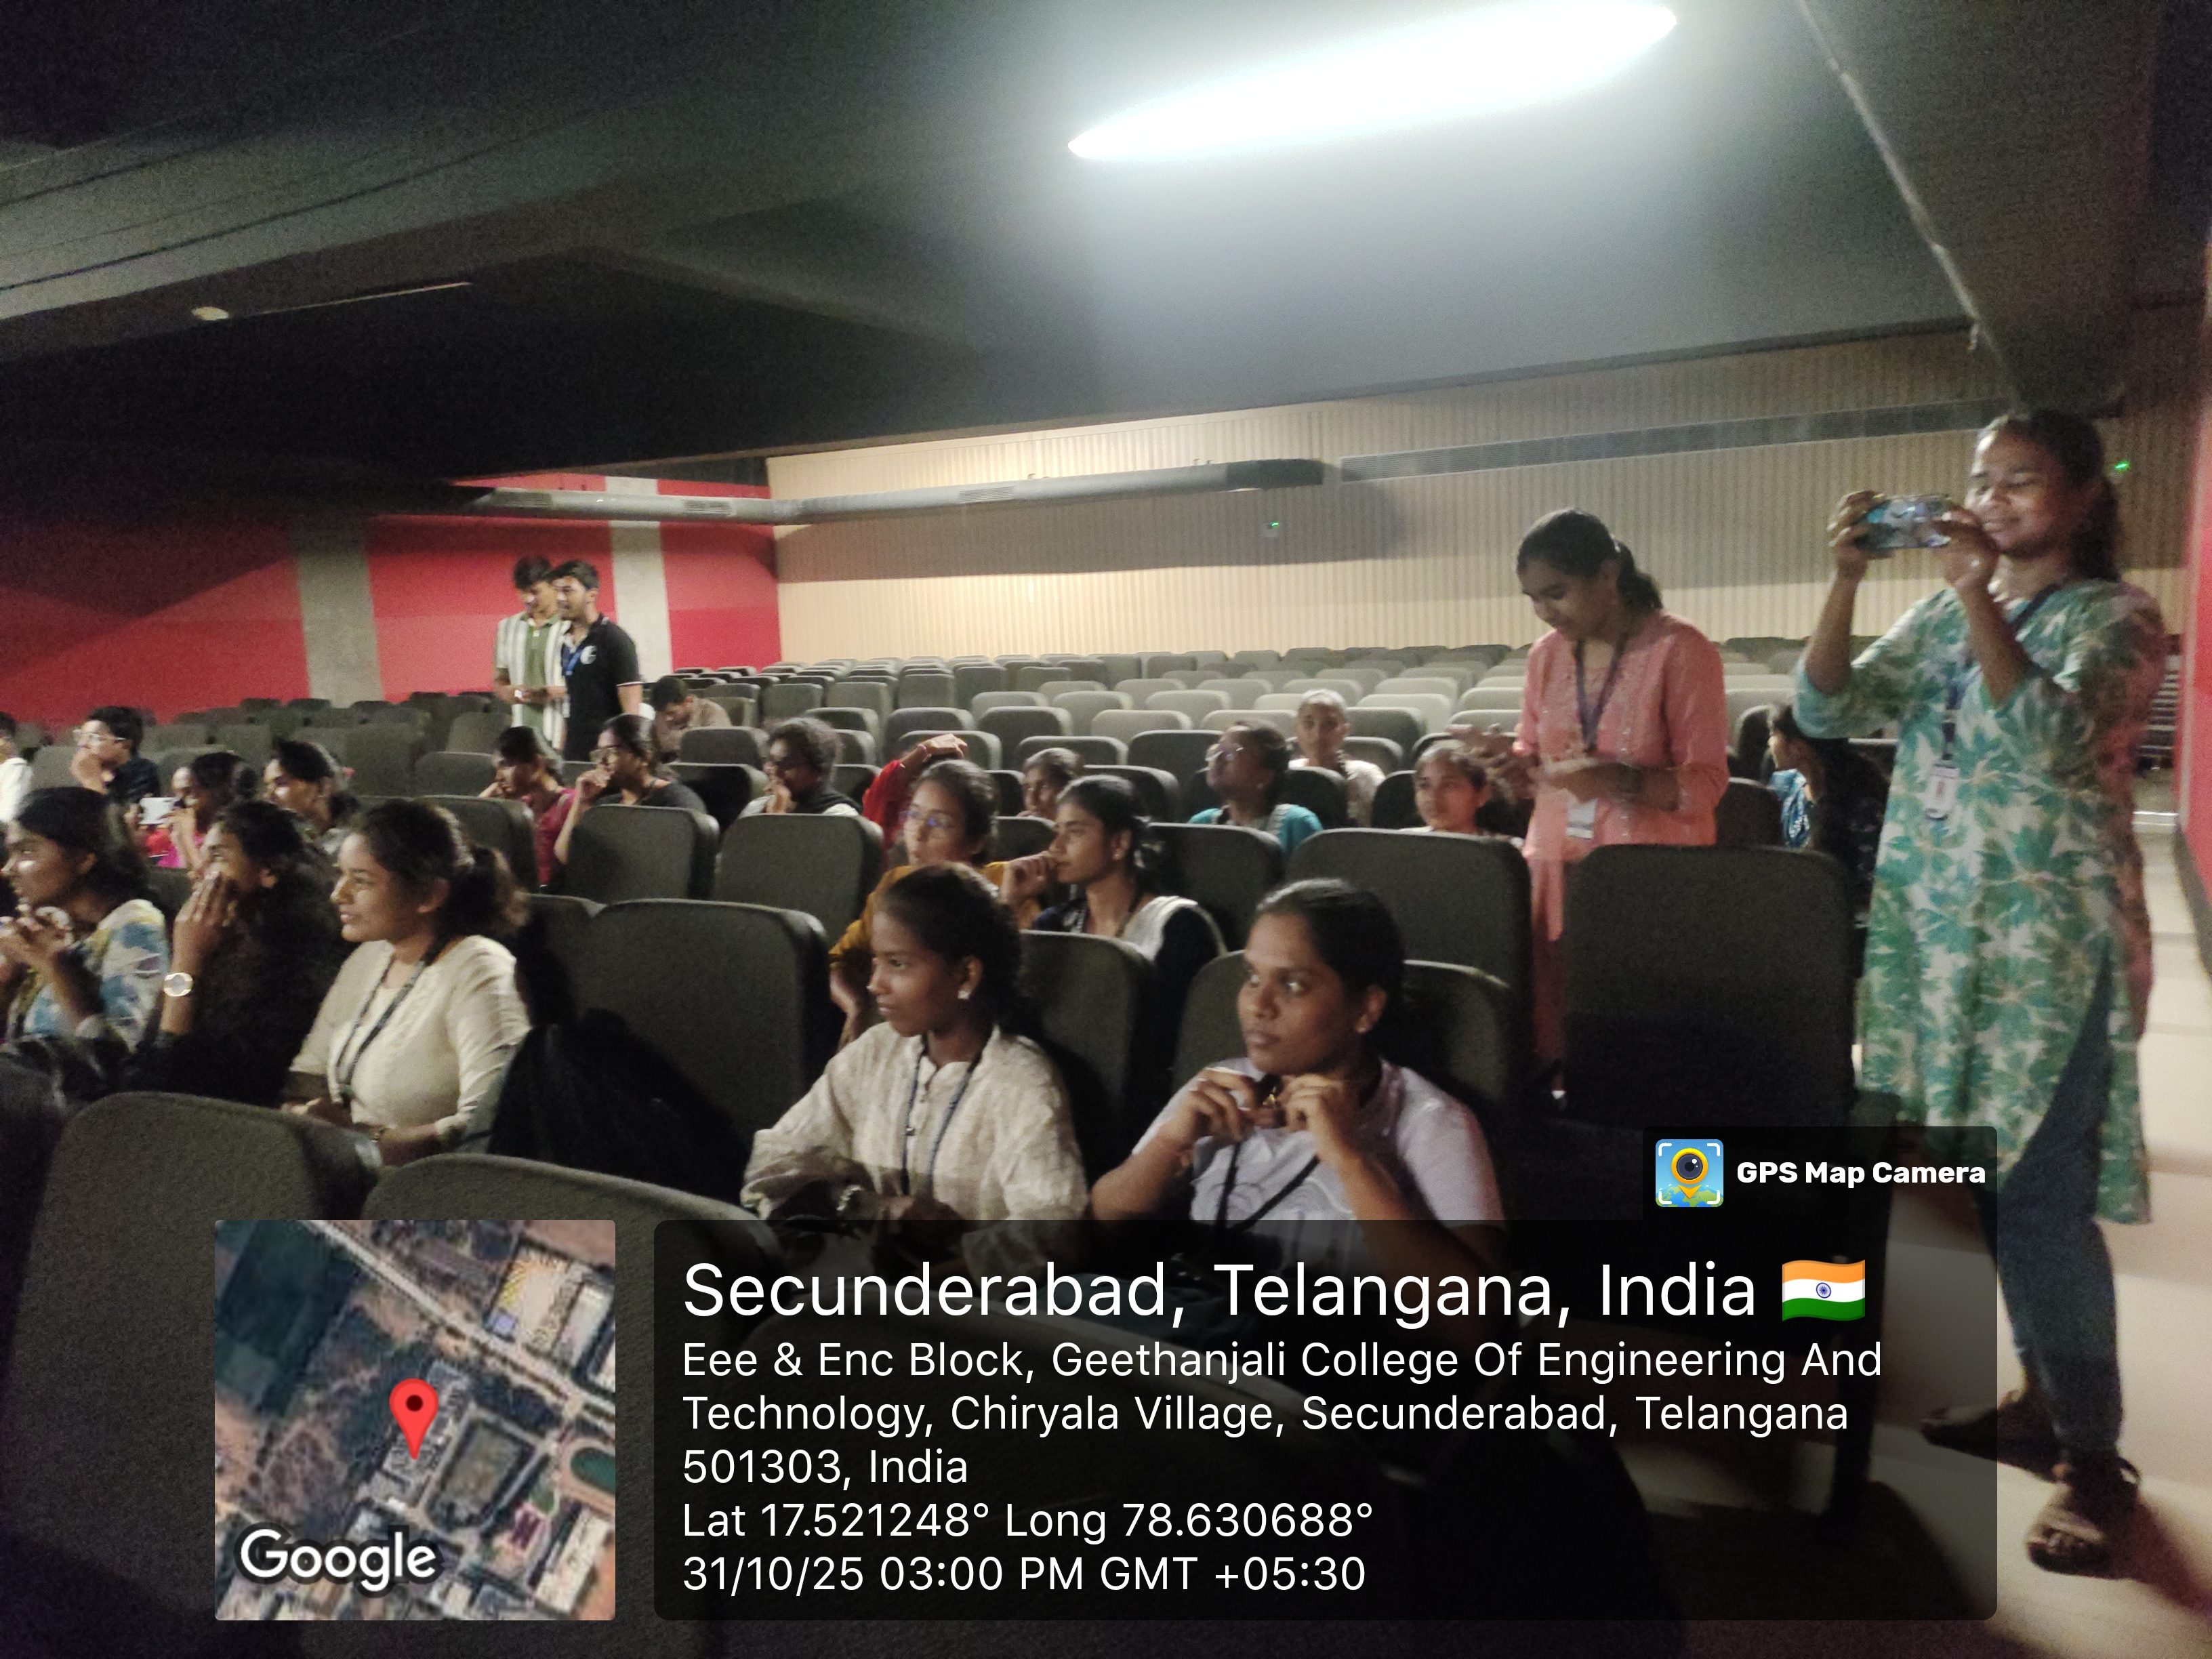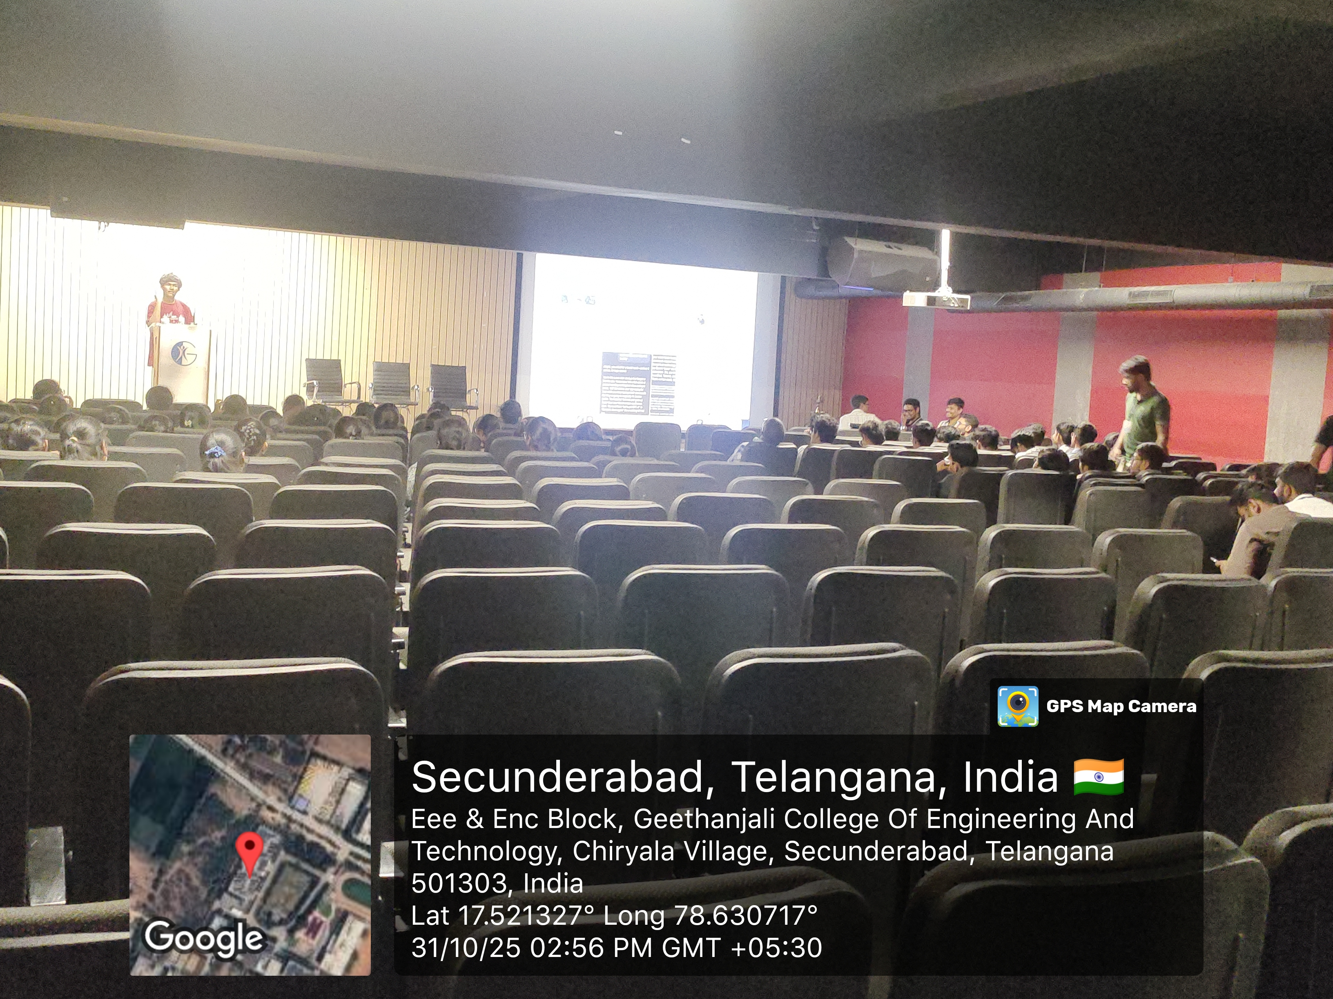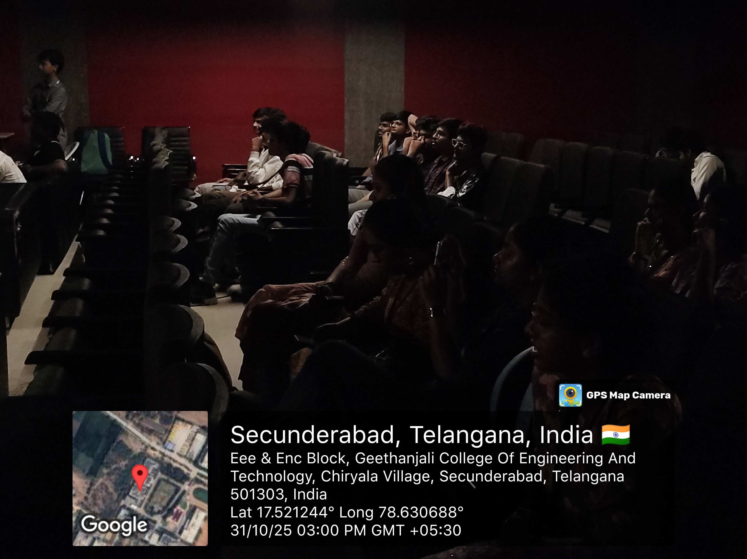

Expenditure: NIL

