
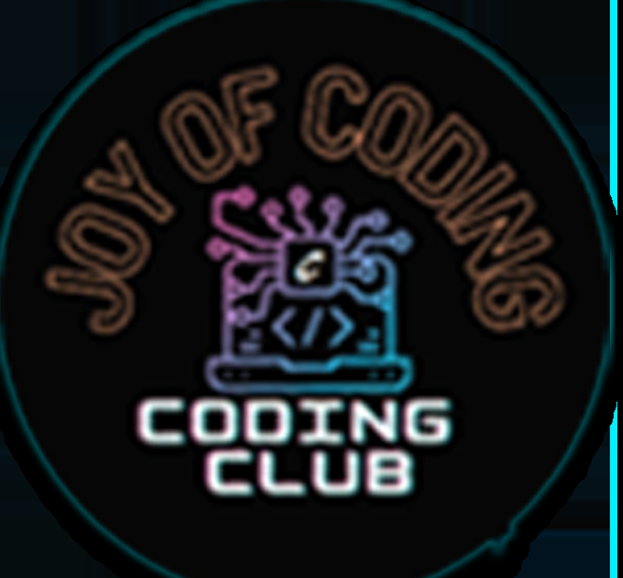
Geethanjali College of Engineering and Technology
(UGC Autonomous)
Accredited by NAAC with A⁺ Grade; B.Tech. CSE, EEE, ECE Accredited by NBA;
Approved by AICTE, New Delhi; Affiliated to JNTUH, Hyderabad;
Cheeryal (V), Keesara (M), Medchal-Malkajgiri Dist., Telangana-501301
Session Details:
Title of the Session: Code Crunch 2.0
Start Date & End Date (DD-MM-YY format): 30-08-2025
Duration: 2 Hours (10:00 AM – 12:00 Noon)
Activity Category: Self Driven – Coding Competition
Theme: Innovation and Skill Development
Objective: To promote competitive coding culture and enhance problem-solving skills among students.
- To introduce second-year students to competitive coding culture.
- To enhance algorithmic thinking and coding proficiency.
- To identify potential talent for advanced technical contests.
- To encourage participation across all engineering branches.

Benefit in terms of Learning / Skill / Knowledge obtained: Students improved logical thinking, algorithmic approach, coding speed, and confidence in competitive programming
Outcome of the Activity: Students gained hands-on experience in solving real-time coding problems and identified their technical strengths. Strengthened interdisciplinary engagement, as students from all engineering branches collaborated and competed.
Relevant SDGs
- SDG 4 – Quality Education
Enhances students’ technical knowledge, problem-solving ability, and exposure to competitive coding, contributing to quality and skill-oriented education.
- SDG 8 – Decent Work and Economic Growth
Equips students with employable programming and analytical skills required for careers in the software and IT industry.
- SDG 9 – Industry, Innovation and Infrastructure
Encourages innovation, algorithmic thinking, and application of modern programming practices to solve real-world problems.
Program Outcomes mapped
- PO1 – Engineering Knowledge
Students applied programming fundamentals, algorithms, and data structures to solve coding problems.
- PO2 – Problem Analysis
Participants analyzed problem statements, identified constraints, and formulated efficient solutions.
- PO3 – Design/Development of Solutions
Students designed and implemented optimized algorithms to meet given problem requirements.
- PO5 – Modern Tool Usage
Used programming languages, compilers, and coding platforms effectively for problem solving.
- PO8 – Individual and Team Work
Demonstrated independent problem-solving skills while engaging in peer learning and collaboration.
- PO11 – Life-long Learning
Motivated students to continuously upgrade their skills and participate in future coding competitions.
Key Highlights: 102 students participated; problems of varying difficulty; prizes awarded to top performers.
Participant Details: 102 Students
Total number of Student Participation (Internal / External if any): 102 (Internal)
Total number of Staff (Teaching / Non-Teaching) Participation: 7 (Teaching Faculty Coordinators from Coding Club)
Geotagged Photographs: Attached
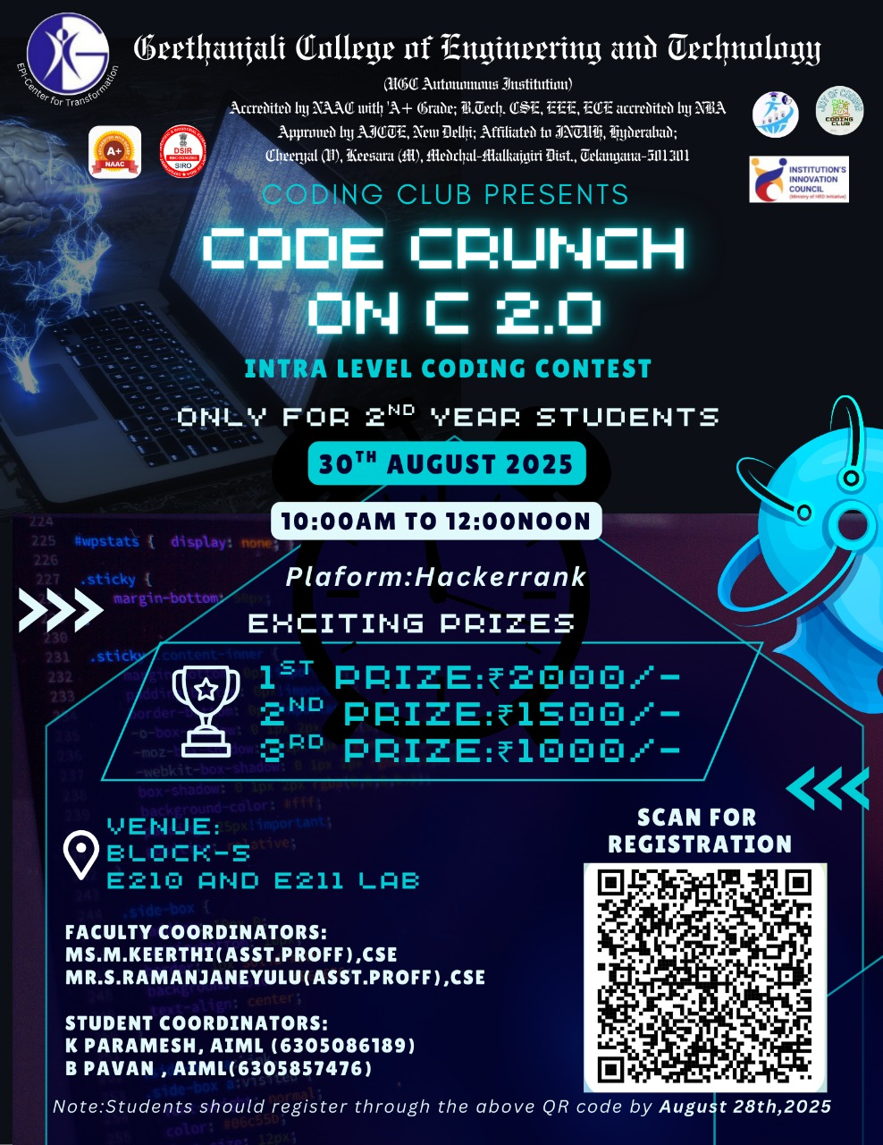

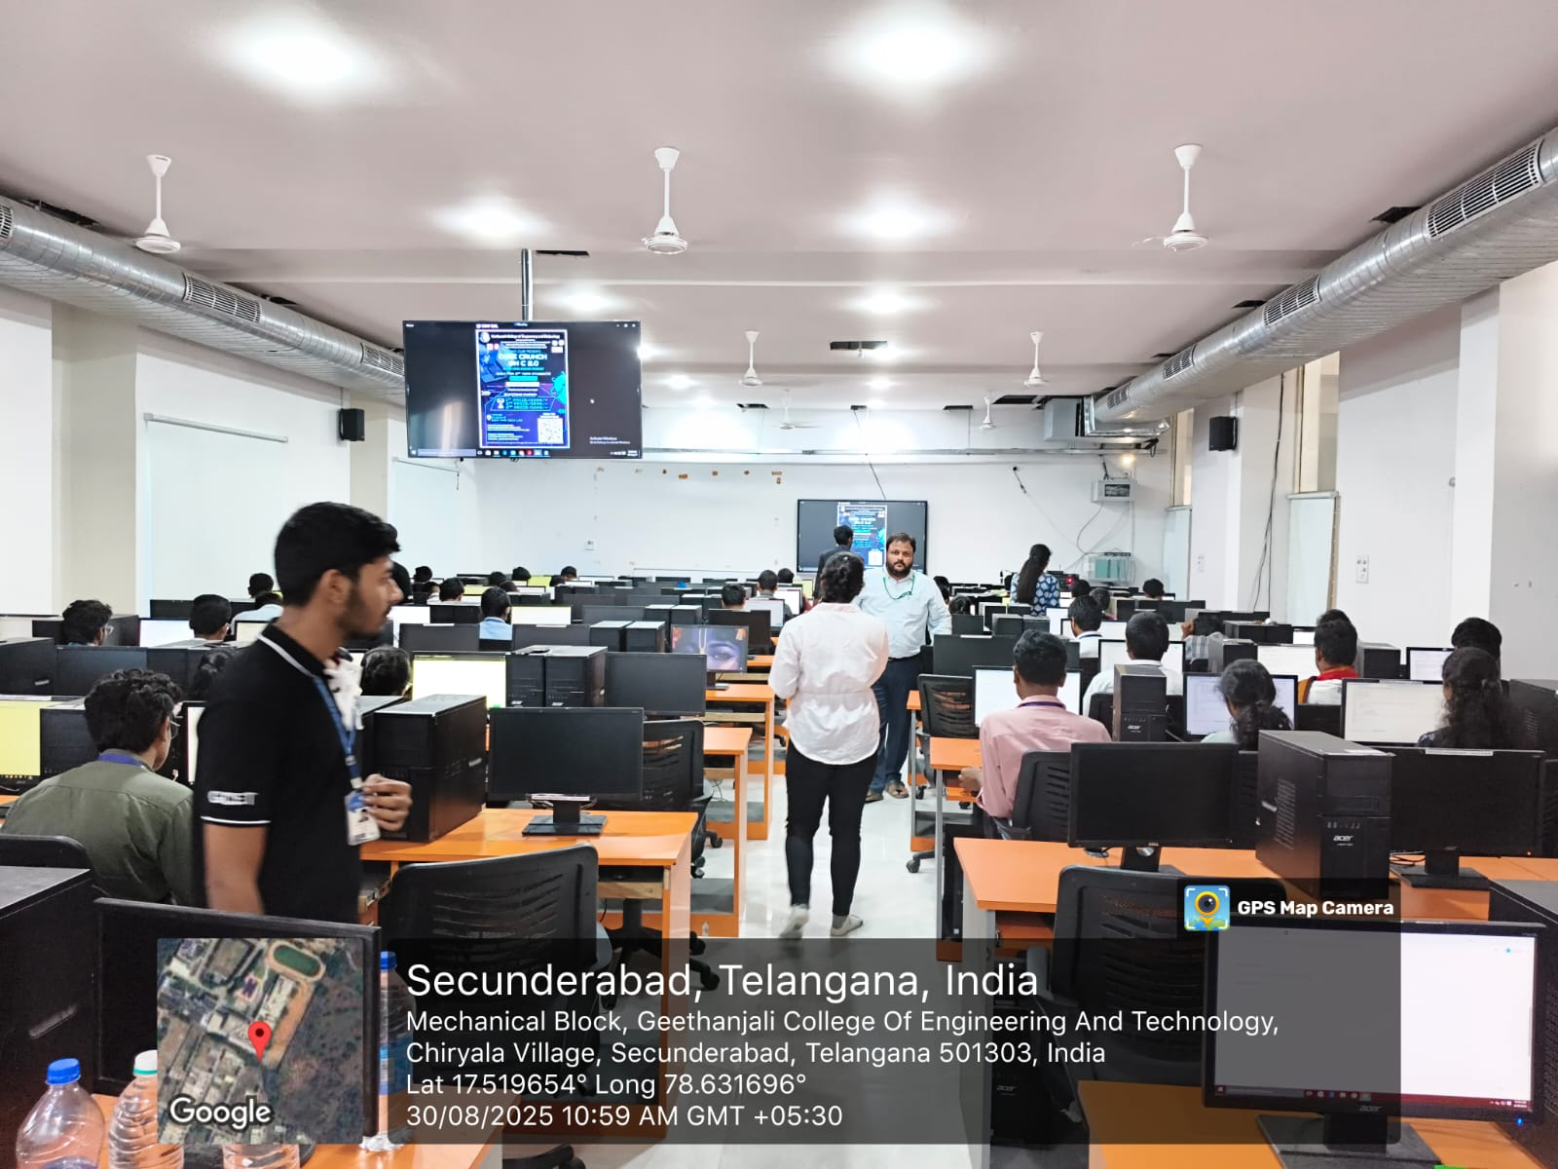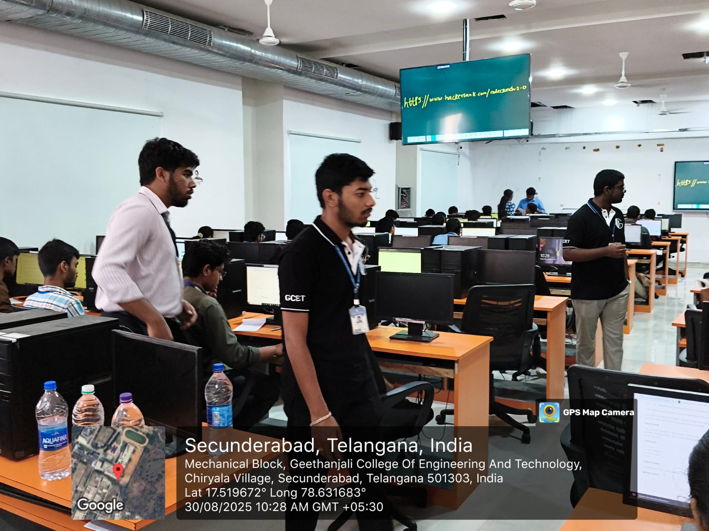

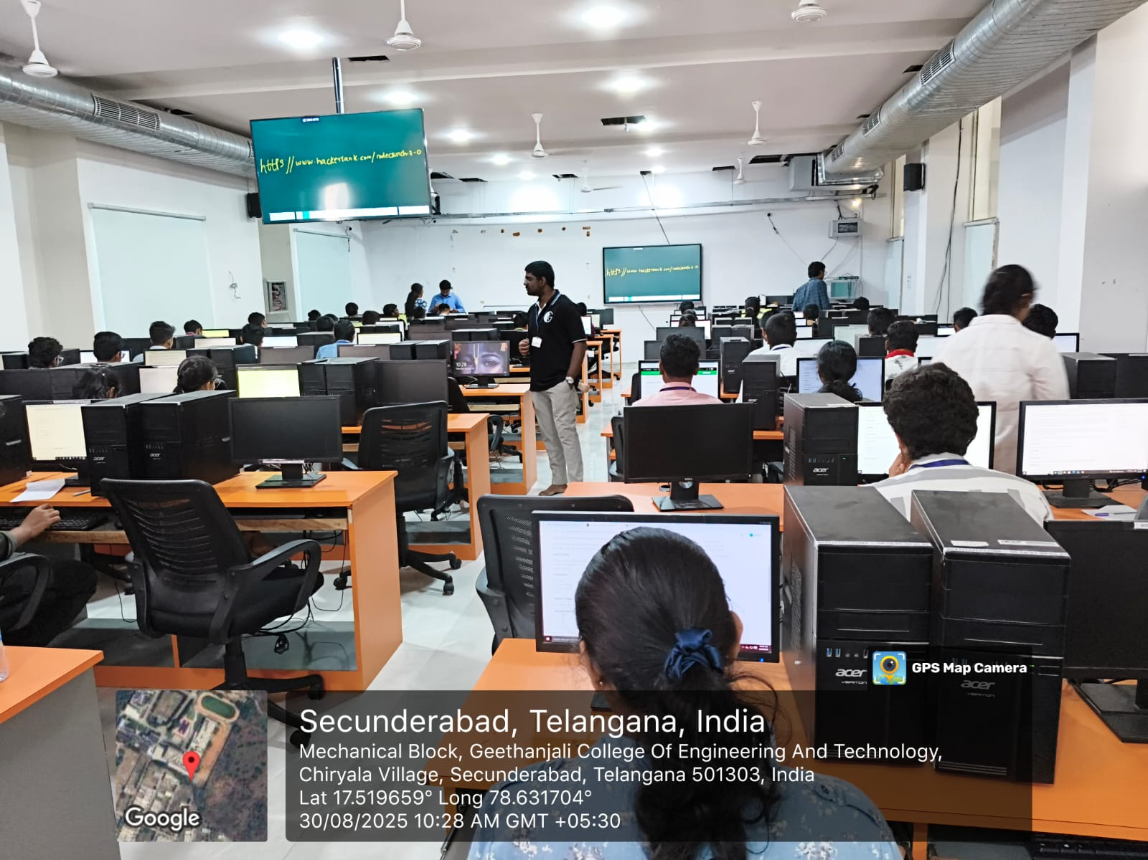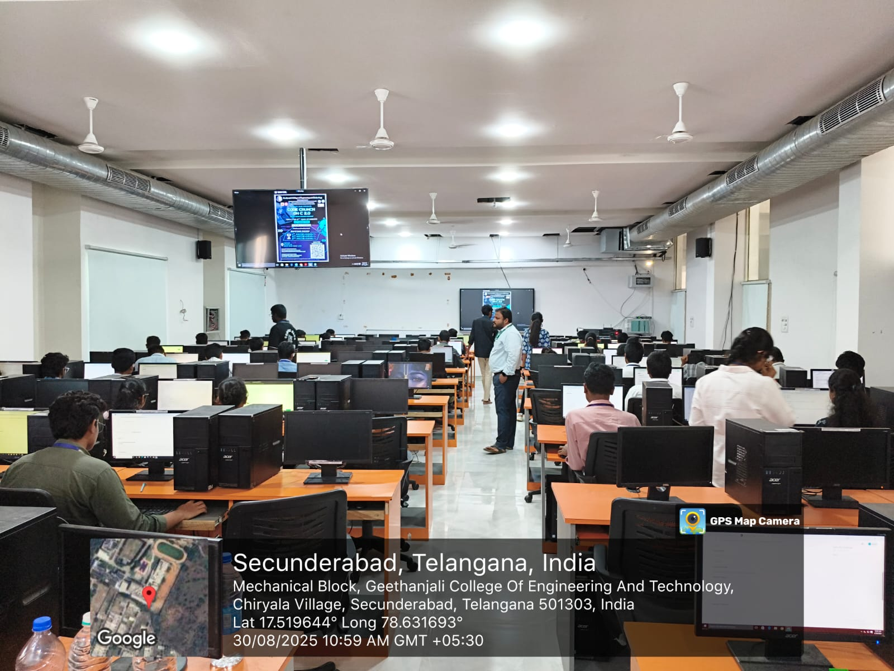
Expenditure: Prize Money: ₹4500

